Spring Data JPA - Quick Example
MYSQL WORKBENCH:
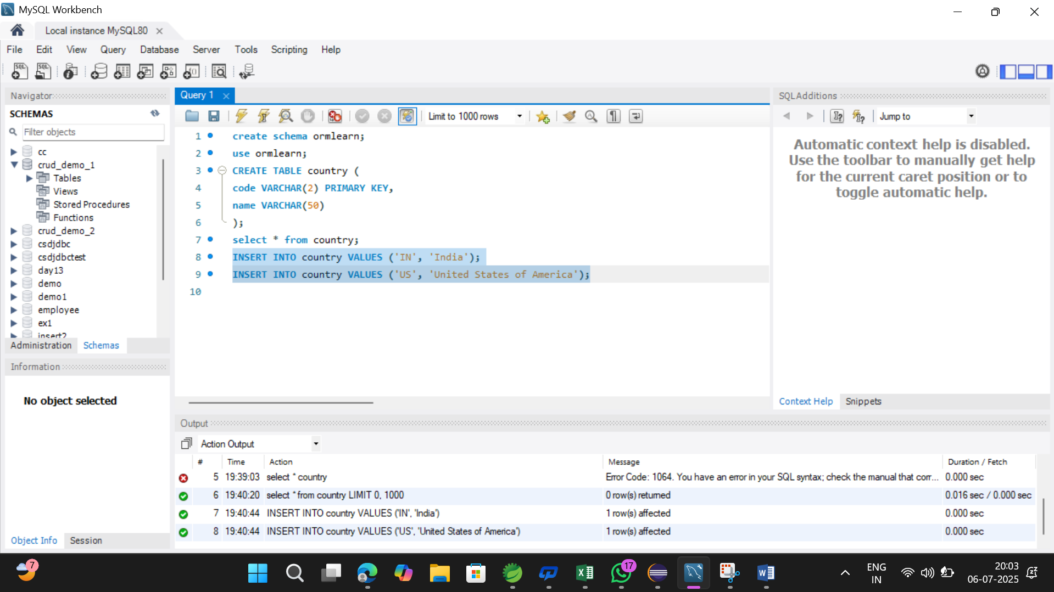

application.properties
# Logging
logging.level.org.springframework=info
logging.level.com.cognizant=debug
logging.level.org.hibernate.SQL=trace
logging.level.org.hibernate.type.descriptor.sql=trace

# Log format
logging.pattern.console=%d{dd-MM-yy} %d{HH:mm:ss.SSS} %-20.20thread %5p %-25.25logger{25} %25M %4L %m%n

# Database
spring.datasource.driver-class-name=com.mysql.cj.jdbc.Driver
spring.datasource.url=jdbc:mysql://localhost:3306/ormlearn
spring.datasource.username=root
spring.datasource.password=root

# Hibernate
spring.jpa.hibernate.ddl-auto=validate
spring.jpa.properties.hibernate.dialect=org.hibernate.dialect.MySQL5Dialect

Country.java:
package com.cognizant.ormlearn.model;

import javax.persistence.*;

@Entity
@Table(name = "country")
public class Country {
@Id
@Column(name = "code")
private String code;

@Column(name = "name")
private String name;

// Getters and Setters
public String getCode() {
return code;
}

public void setCode(String code) {
this.code = code;
}

public String getName() {
return name;
}

public void setName(String name) {
this.name = name;
}

@Override
public String toString() {
return "Country [code=" + code + ", name=" + name + "]";
}
}
CountryRepository.java
package com.cognizant.ormlearn.repository;

import org.springframework.data.jpa.repository.JpaRepository;
import org.springframework.stereotype.Repository;

import com.cognizant.ormlearn.model.Country;

@Repository
public interface CountryRepository extends JpaRepository<Country, String> {
}

CountryService.java
package com.cognizant.ormlearn.service;

import java.util.List;

import javax.transaction.Transactional;

import org.springframework.beans.factory.annotation.Autowired;
import org.springframework.stereotype.Service;

import com.cognizant.ormlearn.model.Country;
import com.cognizant.ormlearn.repository.CountryRepository;

@Service
public class CountryService {

@Autowired
private CountryRepository countryRepository;

@Transactional
public List<Country> getAllCountries() {
return countryRepository.findAll();
}
}

OrmLearnApplication.java
package com.cognizant.ormlearn;

import java.util.List;

import com.cognizant.ormlearn.model.Country;
import com.cognizant.ormlearn.service.CountryService;

import org.slf4j.Logger;
import org.slf4j.LoggerFactory;

import org.springframework.boot.SpringApplication;
import org.springframework.boot.autoconfigure.SpringBootApplication;
import org.springframework.context.ApplicationContext;

@SpringBootApplication
public class OrmLearnApplication {

private static final Logger LOGGER = LoggerFactory.getLogger(OrmLearnApplication.class);
private static CountryService countryService;

public static void main(String[] args) {
ApplicationContext context = SpringApplication.run(OrmLearnApplication.class, args);
LOGGER.info("Inside main");

countryService = context.getBean(CountryService.class);
testGetAllCountries();
}

private static void testGetAllCountries() {
LOGGER.info("Start");
List<Country> countries = countryService.getAllCountries();
LOGGER.debug("countries={}", countries);
LOGGER.info("End");
}
}

Output:
